What Kind of data must be gathered

# Think and Feel

How will they store

How will this data be

useful to them

Will be able to predict diseases based on previous scenarios

# HEAR

Will be useful for research and development

Helps in better understanding of issues

Breach and Unauthorized

amounts of data

***Analytics for Hospitals Health Care Data***

such massive

# Say

Large amounts of datasets

To keep the data more

Different kinds and variations of treatments and diseases

# See

Different kinds of storage

structures

access of Data

Long and Tiring process

secure

# Pain Gain

Much useful for pharmaceutical industry for

Keeping the huge

data safe from

Algorithm used

should not be taking

production of medicines

leakage Should maintain an error free

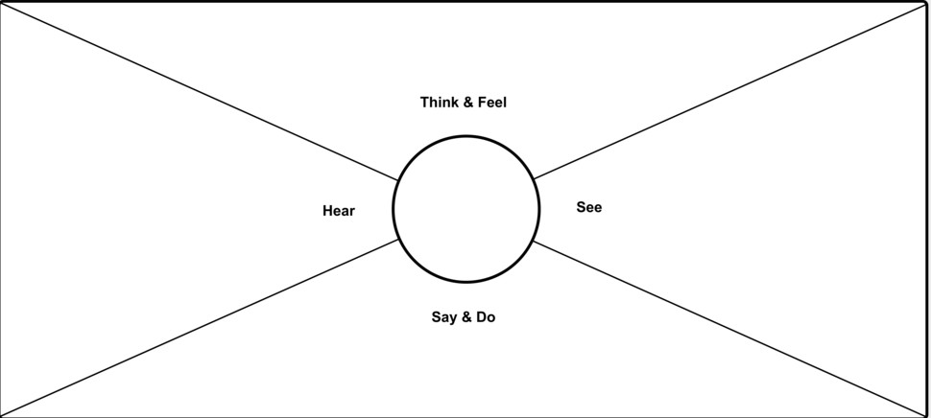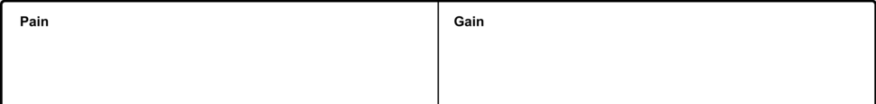

dataset

a lot of time

Helps analyse issues

with different

symptoms

Helps analyse

disease from a broader spectrum